Product Vision
The purpose of this product is to enable gym beginners to simplify their fitness journey by providing personalized workout plans, customized diet recommendations, AI-powered calorie tracking, a fitness accessory marketplace, and a progress tracking dashboard — all within a single integrated platform.
Business Objectives
· Increase User Retention:
Help beginners stay consistent by providing structured guidance, tracking progress, and offering AI-driven support to reduce early dropout rates.
· Generate Subscription Revenue:
Monetize advanced features such as personalized diet plans, coaching, and premium fitness insights while keeping basic access free.
· Create an Integrated Fitness Ecosystem:
Combine workout planning, nutrition guidance, progress tracking, and a fitness marketplace into one platform to eliminate the need for multiple apps or tools.
· Enhance User Results Through Personalization:
Use AI-powered recommendations to help users achieve measurable fitness outcomes such as muscle gain, fat loss, or improved performance.
· Build a Scalable Marketplace Model:
Allow fitness brands, trainers, and nutrition specialists to collaborate and contribute services or products, increasing business partnerships and revenue streams.

Project Scope (In-Scope & Out-of-Scope).
User Registration & Profile Setup
Create account using email/phone
Profile details: age, gender, fitness goal, experience level
Progress Tracking Dashboard
Users can log weight weekly/daily
System visualizes progress using graphs
Motivational alerts (ex: “Great job! You are improving!”)
Marketplace Access
Users can browse gym clothing, weights, accessories
Product listing, categories, filtering
Redirection to purchase (through in-app or external link — confirm later)
AI Chat/Support Assistant (Basic Version)
User can ask fitness-related questions
AI provides general guidance and motivation
Not full personalization yet (comes in later version)
Gym Fee Payment System
Users can find nearby gyms
View membership plans
Pay directly through the app
Store receipts and renewal reminders

Out-of-Scope (for MVP but planned for future releases)
These features are important but will not be part of the first version:
Personalized workout plan
Personalized diet plan
Advanced AI calorie tracking
Subscription model
Community/social interaction
Live trainer communication
Third-party marketplace onboarding portal

Assumptions
Users have smartphones and internet access.
Gyms are open to digital payments and onboarding.
AI model will use predefined responses initially (not fully trained custom AI).

Constraints
Limited budget, so AI and marketplace features start basic.
Gym onboarding depends on partnership agreements.
Legal complaince.

Dependencies
Payment gateway integration
AI chatbot framework (ex: Dialogflow or Microsoft Bot)
Marketplace product provider or supplier integration

Success Metrics / KPIs
Example measurable outcomes:
40% user retention after 30 days
75% onboarding completion rate
20% conversion to paid subscription

Stakeholder Analysis

🎯 Goal: Identify everyone involved in the system and define their role, influence, and expectations.

Primary Stakeholders:
Stakeholder | Role in System | Interest/Expectation | Influence Level
End Users (Gym Members/Fitness Beginners) | Use the app for tracking, payments, and shopping | Easy-to-use app, clear gym subscription options, tracking & motivation | High
Gym Owners / Partner Gyms | Provide membership plans, receive payments, manage users | Simple onboarding, transparent payment settlement, customer acquisition | Very High
Admin (Product Owner/App Company) | Oversees platform and decision-making | Ensure system reliability, revenue growth, and user experience | Very High

Secondary Stakeholders
Stakeholder | Role | Interest | Influence Level
Developers | Build and maintain the platform | Clear requirements and acceptance criteria | Medium
UI/UX Designers | Design user-friendly experience | Understand user pain points and workflows | Medium
Customer Support Team | Assist users and partners | Easy access to system info & support tools | Low–Medium
Payment Gateway Provider (Razorpay/Stripe/UPI) | Handles subscription transactions | Accurate integration, secure payments | High
AI Technology Provider | Provides chatbot model | Clear training data, stable integration | Medium

Stakeholder Matrix (RACI)
Task/Responsibility | User | Gym Owner | Admin | Developer | Support
Register Account | R | — | A | C | —
Manage Gym Plans | — | R | A | C | I
Make Payments | R | I | A | C | I
Track Fitness Progress | R | — | A | — | —
Provide Support | — | — | A | — | R

R = Responsible
A = Accountable
C = Consulted
I = Informed

Key Stakeholder Pain Points (To Address in Design)
Stakeholder | Pain Point | Solution Direction
Users | Don’t know where to start fitness journey | Onboarding wizard + beginner guidance
Gym Owners | Difficult to manage memberships manually | Dashboard + automated renewal alerts
App Admin | Scaling and fraud prevention | Identity verification + secure payment API

👤 User Persona: "The Fitness Beginner"
Attribute | Details
Name | Arjun Kumar (Sample persona name for documentation)
Age Range | 18 – 35 years
Location | Urban & Semi-Urban India (Tier 1–3 cities)
Education | College Student / Working Professional
Income Range | ₹10,000 – ₹60,000/month (varies)
Fitness Goal | Weight loss, muscle gain, general fitness, confidence building, improved lifestyle
Tech Comfort Level | Medium (comfortable with mobile apps, online payments, browsing social media, but not familiar with advanced fitness tools)

🧠 Motivations
Wants to improve physical appearance and confidence
Wants a structured plan instead of random YouTube videos
Wants all fitness needs in one place (gym + diet + workout plan + progress tracking)
Looking for guidance without hiring an expensive personal trainer
Wants visible progress and motivation to stay consistent
Convenience — wants solutions without navigating multiple platforms

😣 Pain Points
Doesn’t know where to start
Confused by too much fitness content online
Gym trainers often unavailable or inconsistent
No clarity on proper diet or calorie intake
Hard to track progress (forgetting workouts, diet logs, missed subscriptions)
Buying gym essentials is time-consuming and scattered across sites

💡 Expected Value From the Product
Expectation | Reason
Simple onboarding and planner | Avoids confusion and decision fatigue
Affordable subscription/flexi-pricing | Budget varies widely
AI guidance & corrections | Wants feedback and confidence
Easy gym membership payments and renewals | Avoids embarrassment of late renewals
Visual dashboard | Wants to see progress and feel motivated

🧩 Behaviors
Uses phone 3–5 hours daily
Watches fitness reels, shorts, and transformation videos
Prefers clear instructions (step-by-step workouts, simple food options)
May skip workouts when stressed or unmotivated

📲 Interaction With the App
Area | User Behavior
Onboarding | Completes questionnaire to generate personalized plan
Gym Subscription | Compares nearby gym plans and selects cheapest or best-rated
Diet & Tracking | Logs meals via quick search or camera if AI scanning available
Workout | Follows beginner plan with demo videos
Marketplace | Occasionally purchases low-cost accessories
Motivation | Uses alerts, streaks, and milestone badges

🧠 Emotional Factors
Emotion | Trigger
Hope | Seeing progress (weight change, streaks, dashboard insights)
Frustration | Complicated UX, unclear instructions, high pricing
Pride | Completing workouts, consistency streaks
Fear | Failure, judgment at gym, losing progress

👤 Stakeholder Persona: Gym Owner
Attribute | Details
Name | Suresh / Priya (Gym Owner Persona Sample)
Age | 28–50
Goal | Increase gym membership & retention
Pain Points | Manual tracking, late payments, lack of visibility, high marketing cost
Expectations | Dashboard, easy onboarding, revenue growth, reminders

Business Requirements (High-Level Requirements)
Req ID | Requirement Category | Business Requirement | Priority | Status
BR-01 | User Onboarding | The system should allow users to sign up using email, mobile number, or social login. | Must have | Draft
BR-02 | Personalization | The system must provide a customized workout plan based on user profile and fitness goals. | Must have | Draft
BR-03 | Marketplace | The system must allow users to browse and purchase fitness accessories through the market place section. | Must have | Draft
BR-04 | AI Features | The system must provide calorie tracking option and provide suggestion based on the input information | Should have | Draft
BR-05 | Subscription | The system must provide 3 Subscription plan so that the user can select their plan in their budget | Should have | Draft
BR-06 | Partner Integration | The system must shows the gym partner model so that the new partners can get to know the information about the partner integration. | Should have | Draft
BR-07 | Payment | The system must provide the option to make payments according to the selected subscription plan of the user. | Should have | Draft
BR-08 | Tracking & Analytics | The system must provide a in-build dashboard to to track the Weights, goals so that the user can have a easy track in their process. | Could have | Draft
BR-09 | Notifications | The system must provide the notification like remainder and alerts so that the user can get to know what they need to do next. | Could have | Draft

Use Case ID | Use Case Name | Primary Actor | Description
UC-01 | Create Account | User | User registers using phone, email, or social login.
UC-02 | Manage Subscription | User | User subscribes, upgrades, or cancels a subscription plan based on their budget.
UC-03 | AI diet generation | User | User can generate customized AI based diet plan with their budget and variety
UC-04 | AI workout generation | User | User can generate customized AI based workout plan according to their need.
UC-05 | Purchase Items | User | User can do purchase accessories or digital items for their workouts need.
UC-06 | Search gym partners | Partner | Gym partners register and list their gym services or offers for user access..
UC-07 | Progress tracking | User | User can able to track the progress on weekly or daily bases using a dashboard.
UC-08 | Notification | User | User can be notified about the daily remainders, alerts and progress notifications.
UC-09 | Make Payment | User | User can able to make payments for the marketplace purchase or premium subscription or gym fee.

UC-01 Create Account
Given the user is on the registration screen
When they enter valid email/phone/social login details
Then the system should create an account
And send a verification message.

UC-02 Manage Subscription
Given a logged-in user
When they select a subscription plan and make a payment
Then the system should activate the subscription
And show the active plan in the user dashboard.

UC-03 AI Diet Generation
Given the user has an active subscription
When they enter fitness goals, dietary preference, and budget
Then the system should generate a customized diet plan.

UC-04 AI Workout Plan
Given the user has an active subscription
When they input workout level and muscle preferences
Then the system should generate tailored workout recommendations.

UC-05 Purchase Items
Given a logged-in user
When they add a product to cart and complete payment
Then the system should confirm the order and send receipt.

UC-06 Search Gym Partners
Given a logged-in user
When they search by city or gym category
Then the system should display relevant gym partner options.

UC-07 Progress Tracking
Given the user updates progress data
When the system analyzes and stores progress history
Then the dashboard should display updated comparison charts.

UC-08 Notifications
Given the user has reminders enabled
When a routine, subscription update, or goal event occurs
Then the system should send notification alerts.

UC-09 Make Payment
Given the user selects a subscription or item
When valid payment details are entered
Then the payment should be processed successfully
And the system should show confirmation and invoice.

Risks & Mitigation
Risk | Impact | Likelihood | Mitigation
Low adoption | High | Medium | Offer trial plan
Data accuracy concern | Medium | High | Verify food database

Glossary
Term | Definition
Subscription | Paid access to premium features
AI Recommendation | Automated food/workout suggestion system

Use Case Diagram :

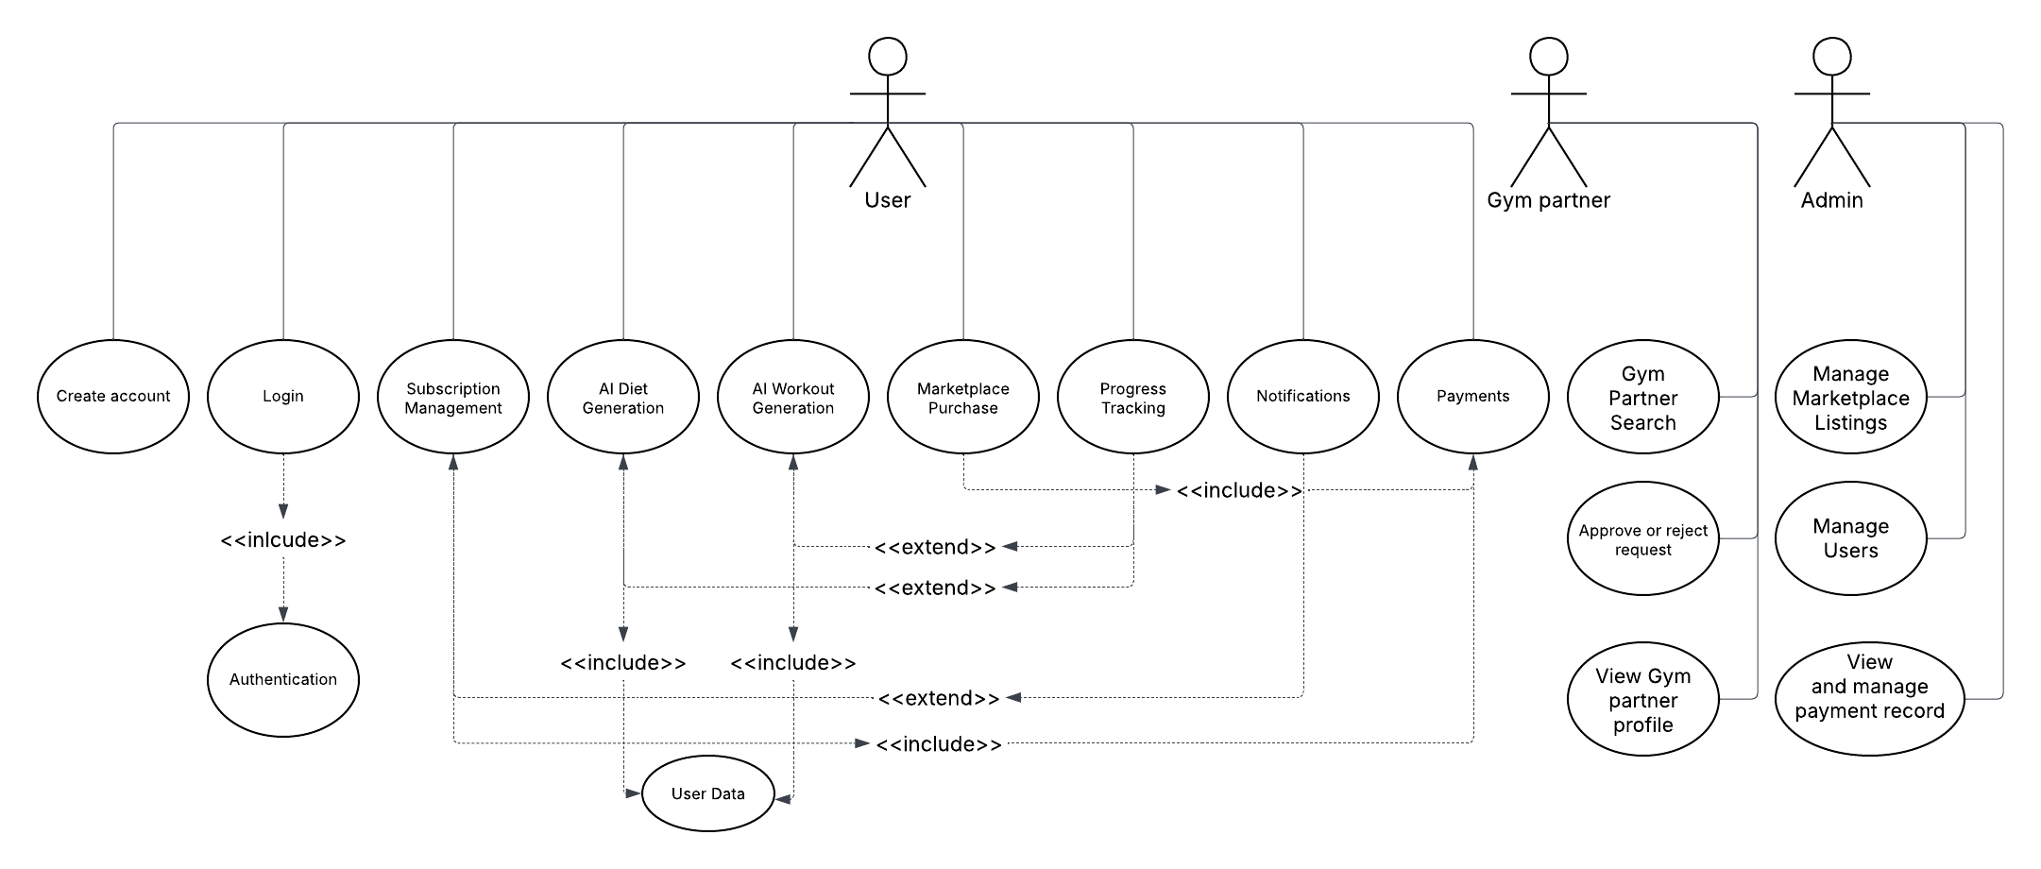

Approval / Sign-off

Final page with signatures:
Business Sponsor
Product Owner
BA (Monish)
Developer Lead

